Advance Computer network PCS223
Assignment-7
Suryansh Sharma 8025320099

Objective
- To understand the Link State Routing algorithm (OSPF)
- To configure and verify OSPF routing in a network
- To analyse how Shortest Path First (SPF) algorithm works
Problem Statement
Design and implement the given network topology with three routers (R1, R2, R3), two LANs, and PCs. In addition to configuration, analyse route selection using OSPF cost and SPF algorithm
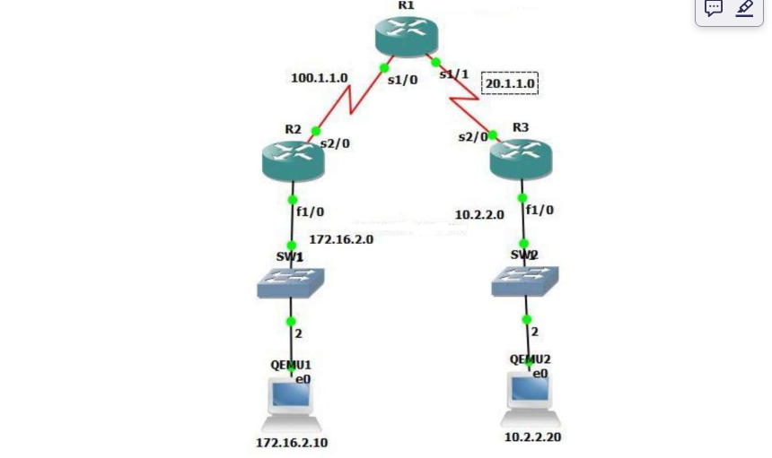
Network Topology & IP Addressing
- 3 Routers: R1, R2, R3
- 2 LANs
- Serial links between routers
- PCs connected to R2 and R3

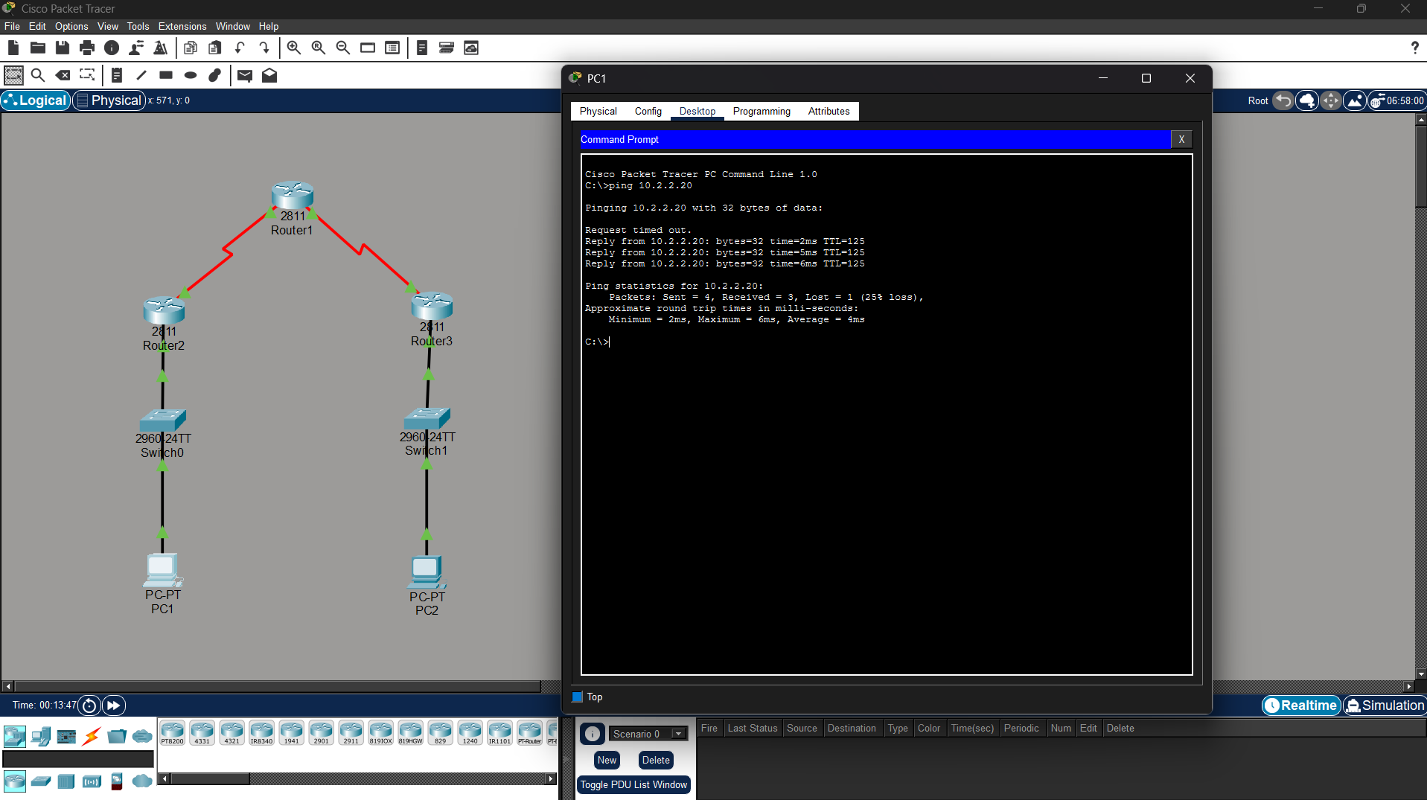
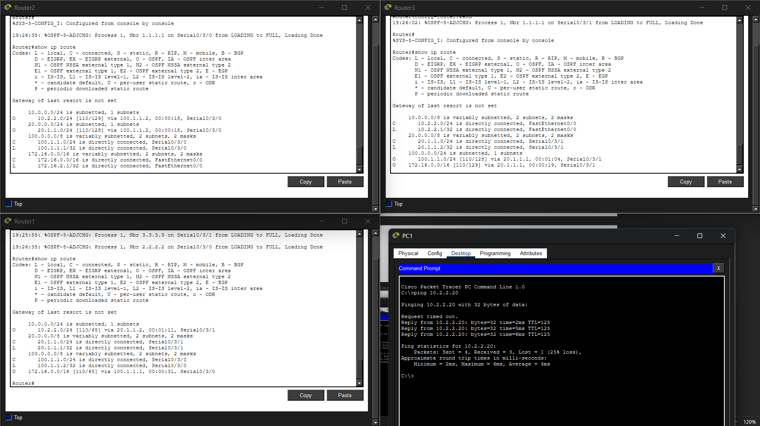

Successful communication between networks was achieved using OSPF routing protocol.

